EcoSort AI: No-Code Waste Classification
Project Report
Prepared by: Farha Kousar
Platform: Google Teachable Machine
Project Type: No-Code AI Image Classification

1. Abstract
EcoSort AI is a no-code image classification project developed using Google Teachable Machine. The project demonstrates how artificial intelligence can classify waste images into three categories: Plastic, Paper and Cardboard, and Metal. The model was trained using image samples and tested through the platform's preview feature.

2. Problem Statement
Identifying different types of waste is an important step toward effective waste segregation. This project explores whether an image classification model can recognize visual patterns in plastic, paper/cardboard, and metal objects.

3. Objectives
- Build an AI image classification model without coding.
- Create three labeled image classes.
- Train the model using Google Teachable Machine.
- Observe model predictions using the preview feature.
- Understand the limitations of image-based waste classification.

4. Tools Used
- Google Teachable Machine
- Image samples for three waste categories
- Computer and web browser

5. Dataset
The project contains three classes:
- Plastic: Plastic bottles, caps, packaging, and containers.
- Paper and Cardboard: Paper sheets, cardboard boxes, and paper waste.
- Metal: Metal scraps, cans, and other metal objects.
At the time of the captured screenshot, each class contained 7 image samples, giving a total of 21 samples

6. Methodology
- Opened Google Teachable Machine.
- Created an image classification project.
- Added the Plastic, Paper and Cardboard, and Metal classes.
- Uploaded image samples into the respective classes.
- Trained the model using the platform's training feature.
- Tested the model using the preview panel.
- Captured a screenshot of the trained model and its prediction.

7. Results
The model reached the Model Trained status.
- When the displayed image of colorful plastic bottles and containers was tested, the model predicted Plastic with 100% displayed confidence.
- This result represents one observed prediction. It does not establish 100% overall model accuracy

8. Testing and Evaluation
The model's performance should be evaluated using new images that were not included in the training dataset. Predictions should be recorded and compared with the correct labels.
Accuracy can be calculated using:
Accuracy = (Correct predictions ÷ Total test images) × 100
An overall accuracy score has not yet been established.

9. Limitations
- The current dataset is small, with 7 samples per class in the screenshot.
- Different lighting conditions and backgrounds may affect predictions.
- Composite or contaminated waste can be difficult to classify from images.
- Model confidence does not guarantee a correct prediction.
- Actual recycling suitability depends on local recycling guidelines.

10. Future Improvements
- Add more diverse images to each class.
- Test the model using unseen images.
- Record correct and incorrect predictions.
- Calculate accuracy from actual test results.
- Improve the dataset with different backgrounds, lighting conditions, and object types.

11. Conclusion
EcoSort AI demonstrates the basic workflow of creating image classes, training an AI model, and viewing predictions without writing code. The model successfully reached the trained state and predicted Plastic for the displayed plastic-container image. Further dataset expansion and systematic testing are required to assess its reliability.

Appendix: Project Evidence
Insert the screenshot showing the three image classes, the “Model Trained” status, and the Plastic prediction.
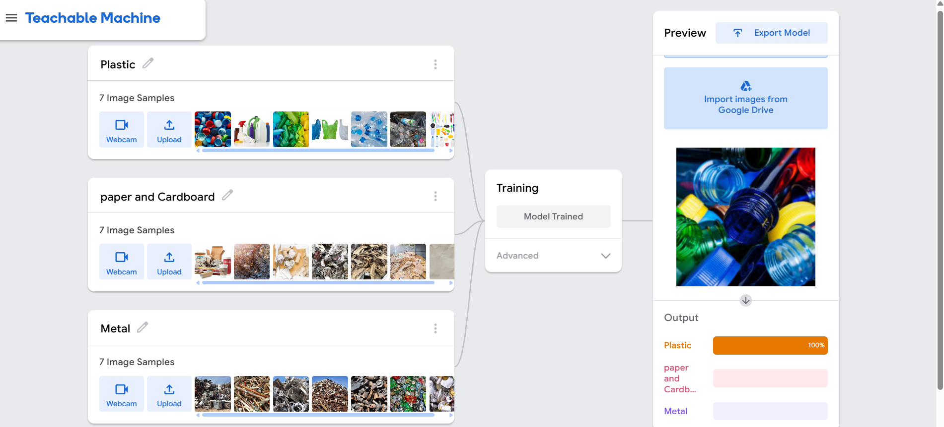
Project status: Initial prototype trained; further evaluation recommended.

